Olfactometer software MolfControl

The control software developed by Burghart Messtechnik enables the user to easily use the olfactometer semi-automatically. Create your experiments and odorant presentations comfortably on the computer. The control screen is clearly arranged and allows quick access to experiments and monitoring functions.

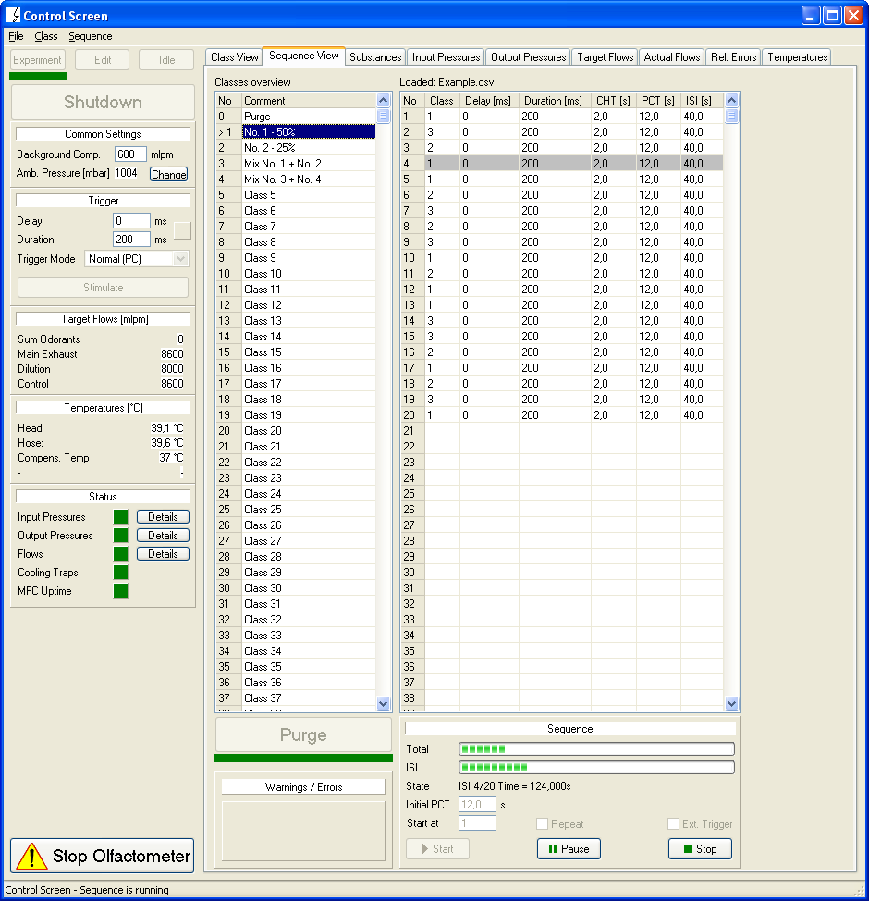

The control software MolfControl, is part of the devices and can only be used for the olfactometers OL022, OL023 and OL024. The system requirements can be found in the data sheets. Training in the use of the software is always included with every purchase of one of the olfactometer variants mentioned.

Features of the software

- Guided workflow with images and description
- Guided start-up, device preparation, heating up and shutting down
- Detailed display of the current flows
- Background compensation (OL023, OL024)
- Display of target flows
- Detailed monitoring of operating parameters such as inlet pressure, outlet pressure, water temperature, operating temperatures as well as humidities
- Warnings for excessively humid air in the air supply system
- Automatic heating at a set time (timer). Unit is prepared in the evening and is immediately ready for testing the next morning
- Regular reminder of upcoming cleaning cycles from the day they are due
- Storage and loading of fragrance classes
- Flexible specification of stimulus sequences incl. saving and loading of already created experiments (sequences)
- Interval of stimuli
- Duration of stimulus
- Stimulus can be triggered externally via TTL signal
- Output of class number and stimulus time as TTL signal for external devices
- Output of an additional trigger signal, delayed relative to the stimulus
- Coloured display of the machine status. Errors are summarised as colour and displayed
- Log file (experiment log, general log)
- On request: feedback controller
- On request: remote control via network

